Customer segmentation using

Data science

Team Members:

1.TAMIL SELVAN T

2. MUTHUMARIYAPPAN V

3. RAHUL K

4.PANDIYARAJAN R

5.ARUNKUMAR A

**INTRODUCTION**

Retail banks deal with various problems during business expansion. Over the years, banks have been trying to expand their customer base without taking into full consideration the value each customer brings now and is able to bring in the future. Customers leave behind a large footprint in terms of the transactions they perform, which can be analyzed to determine who the most valuable customers are and how to nurture and grow the business by leveraging the existing customer base.

The main idea behind taking up the study of Czech Bank is to understand their existing customers – their transaction patterns, product holdings, demographics, past trend, and other attributes and behavior with the bank to devise an effective strategy. Czech Republic Bank is a banking group that offers major retail banking services. The services include managing savings and current accounts, offering loans and credit card services.

The bank is functioning since 1994 and has a large number of customers. The bank has determined that if it can devise any strategy to tap potential around its existing customer base, then it can scale up business quickly in a more cost-effective manner as there is no acquisition cost. These customers are already banking with them; they need attention, service, and hand-holding.

The bank wants to target its services to the selected groups of customer segments, created by differentiating between valuable and non-value-add customers. Currently, the bank works on gut feelings, without a strategy based on analytics, regarding which customer to target (whom to offer an additional service) and who is a potential risk.

To help formulate an effective strategy for business expansion, the following two objectives were taken up.

* Profiling to classify each customer into either profitable or non-profitable buckets
* Profiling profitable customers into various segments to customize product offerings to increase the overall business of the bank

###### 

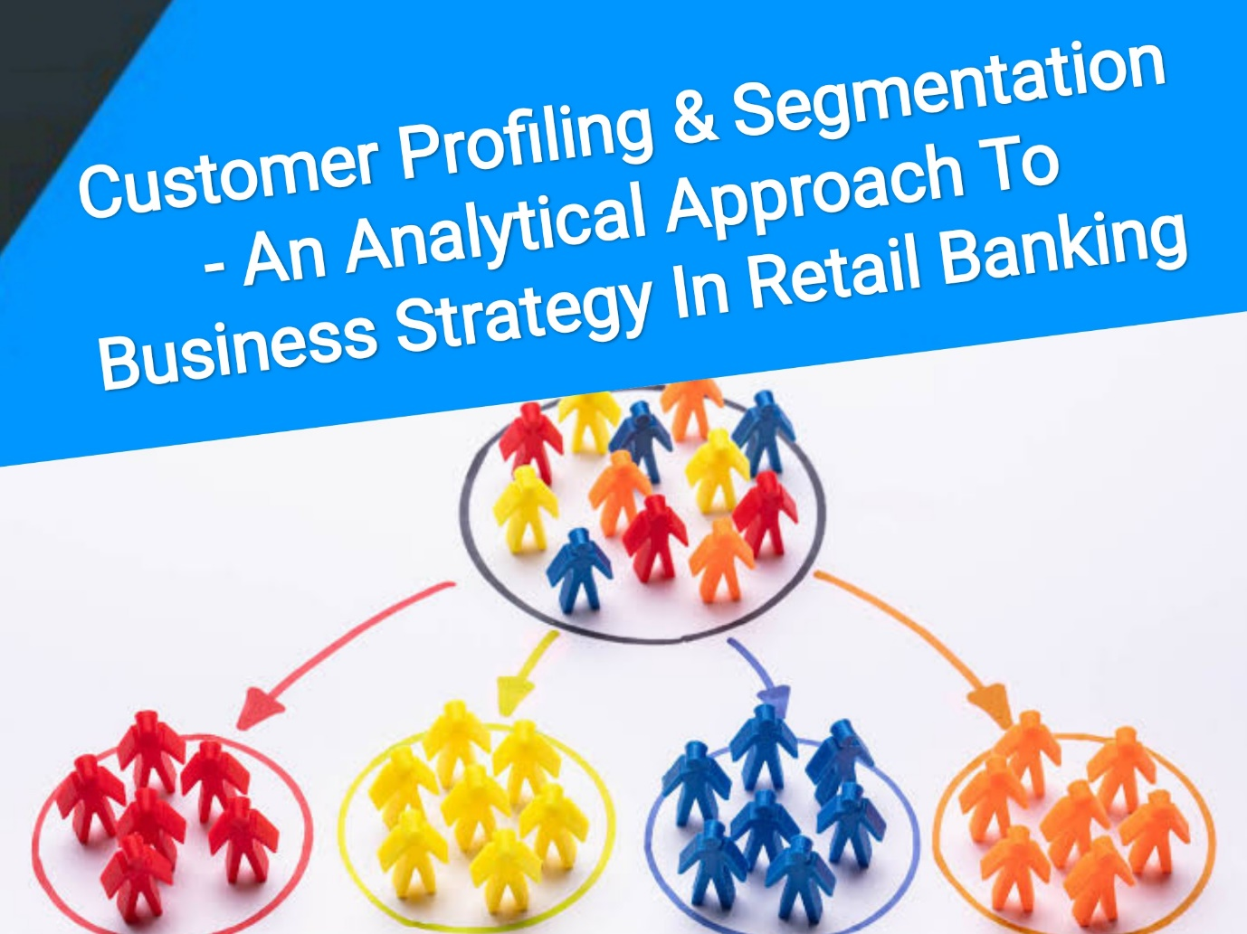

## LITERATURE REVIEW

The dataset of the Czech Bank was available in the public domain since 1999. Most of the analytical study in the financial analytics domain has been done around default prediction, fraud risk, preventive forecast, credit card analysis. We have extended this study in customer profiling and segmentation part using the analytical approach – clustering technique and scorecard. RFM (Recency Frequency Measure) being the most frequently used technique in the retail banking domain for customer segmentation.

Customer Profiling and Segmentation play a pivotal role in deriving customer service strategies which in turn enhances customer satisfaction levels as well as to gain market positions. The inability to discover valuable information hidden in the data prevents the organizations from transforming the data into knowledge. Effective customer relationships require an understanding of what the relationship entails and the ability to provide personalized services, a means for building mutual value and respect, and a commitment to the relationship itself. By identifying the associations between products purchased in point of sale transactions, retailers can develop focused promotion strategies.

The clustering technique used for data mining is the key to bringing business intelligence to more varying disciplines and intricate tasks in retail that enables precise insights and patterns by providing an in-depth understanding of the behavioral and demographic patterns and also to identify main characteristics of the customers in each segment to retain the existing profitable customers. Effective communication is very difficult to establish in a retail bank with various product offerings, so it is necessary to divide customers into groups, whose members have similar characteristics to ensure ease of targeting, marketing, and offering personalized products to retain the customers. The paper has segregated the customers into different clusters based on demographic data, product holdings, and transactional behavior patterns as well as classified each customer into either profitable or non-profitable. This has been further used to guide the bank to formulate its business strategy and product mix offerings.

Benefits of customer profiling and segmentation:

* More customer retention
* Enhances competitiveness
* Establishes brand identity
* Better customer relationship
* Leads to price optimization
* Best economies to sale
* Improves channel of distribution
* Increase profit by keeping costs down
* Identify potential customers
* Improves Customer Engagement and Brand Loyalty

Data:

The data for the project has been sourced from the internet; a real anonymized banking transactional dataset of Czech Bank from 1st Jan1993 to 31st Dec 1998. It’s based on the 5 years’ data – approximately data volume is about 1 million transaction records comprising of 4,500 unique customers. Please refer to the below link to access data: http://sorry.vse.cz/~berka/challenge/pkdd1999/data_berka.zip

There were also some interesting results of classification according to loans (running loans with no problems, running loans with the client in debt, finished contract with the loan paid off, finished contract with the loan not paid) and according to credit cards (does not own credit card, owns the junior card, owns the classic card, owns gold card). Only 15% of clients had loan contracts, out of them only 11% of loans were with problems (running or finished). Similar proportions hold for the credit cards as only 20% of clients used credit cards, out of them only 10% (2% of all clients) used gold cards.

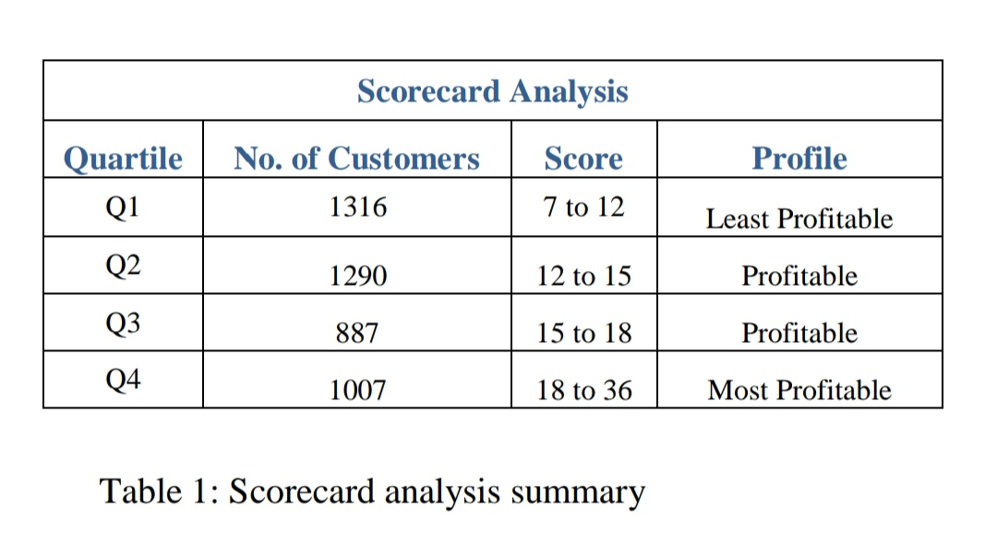

**Technique Used: K-Means Clustering Algorithm**

The purpose is to segregate the Profitable bank customer base into different customer segments, thus ensuring ease of targeting and communication so that the bank can offer the bundle of products or services to the different band of customers that is most likely to buy from the bank. For the customer segmentation and to study the behavioral data based on customer’s transactions and their demographics, we have done feature selection for the available data.

We segregated the customer base into 3 different segments on the basis of their product holdings, traits, and transactional patterns. Our approach to arrive at a solution with 3 clusters was mainly focused on identifying different customer segments with common traits and holdings, demographics, and transaction behavior, so that the bank may understand the trend and customize offerings accordingly. In addition, if we are able to identify products that have similar customer attributes, then we can highlight cross-sell or up-sell opportunities towards targeted customers.

For modeling this objective, we have used K-Means clustering. In this, we have found out the best value of parameter K, i.e. K=3 with the help of the Elbow method. After clustering, we found that the below mentioned 10 variables play the most significant role in clustering:

* household_payment
* having_loan
* oldagepension_payment
* average_salary
* age
* having_creditcard
* numberof_credit_transactions
* numberof_debit_transactions
* average_monthly_balance
* insurance_payment

##### CLUSTERING RESULTS

**Out of the base of 3184 Profitable customers, Cluster 1 is having the highest population of customer concentration with a total number of 2199 customers and on the other side Cluster 2 is having the least number of customers with a total of 462 customers. Cluster 3 is having 523 customers**

***We have profiled these clusters descriptively:***

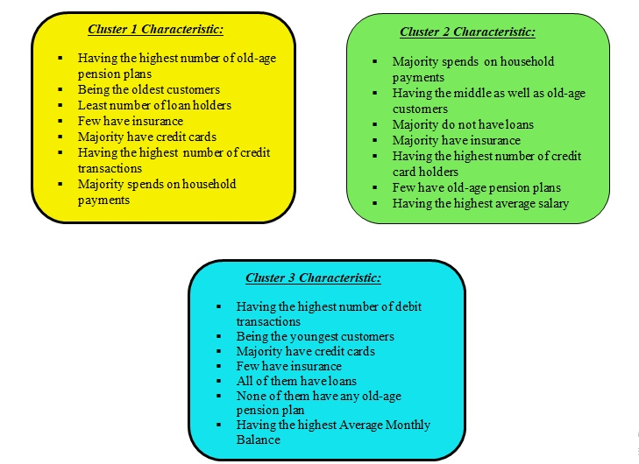

**RECOMMENDATIONS**

***Cluster 1:***This is the largest cluster for the bank hence needs the most appropriate targeting and product offering. The bank may offer traditional banking products like fixed deposits, term insurance, medical insurance, general insurance, and debt investment plans as this group does not seem to be willing to take any higher risk equity products.

The bank must consider them suitably eligible for insurance products as increasing age will lead to increased medical and health-related expenses. The bank has a wonderful opportunity to propose them investment plans with moderate risk exposure, pension plans coverage, and also approach them to create an investment corpus to ensure a stress-free retirement period.

***Cluster 2:***The bank should offer them some promo-based cashback offers and discounts to further increase the usage of credit cards for household payments. The bank may target this cluster for credit card up-gradation like Silver to Gold, or Platinum variants with higher credit limits. This group also can be offered premium concierge services on a chargeable basis. The salary account holders may be upgraded to Wealth and Private banking platforms so that customers feel more important.

The bank should target them for household durables, easy EMI products, and purchases related to children. As the profile suggests, these are least likely to default and must be targeted for loan cross-sell as this will help to increase profitability and stickiness. Old-age pension plans must be adequately sold to this cluster.

***Cluster 3:***The bank must target this cluster for credit card upgrade schemes along with lifestyle-based offers on cards. As the profile suggests, this cluster has not started the retirement planning yet so the bank must sensitize this cluster to start pension planning immediately and must offer related product solutions as well. The bank should offer insurance plans related to life, health, and general categories.

The bank may also offer attractive interests on loans or unsecured loans with a higher rate of interest and processing fees. This cluster also has a very high average monthly balance that means funds remain idle in a savings account at a low-interest rate. The bank must offer better interest-yielding products like fixed deposits, mutual systematic investment plans, and overdraft products to this cluster.

**APPLICATION AND CONCLUSION**

The outcome of this study is based on a data-driven analytical approach that will empower the bank to devise an effective marketing strategy to increase its profitability by targeting potential customers from its existing customer base, thus ensuring optimization of resources. This will enable the bank to target and sell to those customers competitively and economically that are most likely to buy their products or services as the bank now understands its customer’s requirements very well. With the help of scorecard and clustering output, the bank can identify the most profitable and potential customers along with their characteristics and devise various strategies to move them up to the higher profitability bands.

From the scorecard analysis results, out of the base of 4500 customers, we identified 3184 customers (falling in Q2, Q3, and Q4) are the potential and profitable customers that add value to the bank’s profit. The bank should target this segment further to increase its revenue. In addition out of 3184 customers, 1007 customers (falling in Q4) are the most profitable ones for the bank. The remaining customers (falling in Q1) do not add value to the growth of the bank’s business and would be better if these can be let go off and this will also reduce the cost that incurs in their retention.

To further define the strategies to increase the revenue from these profitable customers, we profiled them into 3 separate clusters. Each cluster uniquely provides insights into their needs and requirements. The bank could use these insights to create customized offers and custom plans to cross-sell or up-sell more products and services to those currently having low product holdings, and this will lead the bank towards higher product penetration, profitability, and capturing appropriate market share. This will also increase customer loyalty towards the bank. More loyal customers will help in improving revenues and profits for the bank.

**End Notes:**

These analytical models or techniques (scorecard and clustering) used in this study are generic in nature and not specific to the case in point. These models can find a wide application across the financial services industry.